**Assignment no 7**

1)

#include<iostream>

using namespace std;

class first

{

public:

int a,b,c;

void read()

{

cout<<"enter the value of a and b :";

cin>> a >> b;

}

void cal()

{

c = a+b;

}

};

class second : public first

{

public:

void dis()

{

cout<<"\n addition is : "<<c;

}

};

int main()

{

second s;

s.read();

s.cal();

s.dis();

}

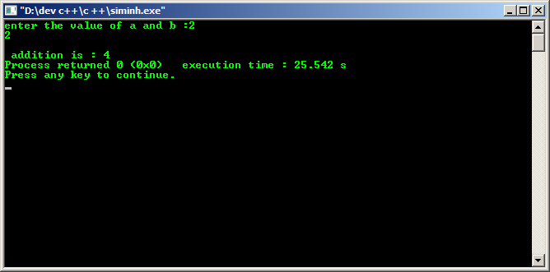

2)

#include<iostream>

using namespace std;

class first

{

public:

int a,c;

void read()

{

cout<<"enter the value of a side:";

cin>> a ;

}

void cal()

{

c = a*a;

}

};

class second : public first

{

public:

void dis()

{

cout<<"\n area of a square is : "<<c;

}

};

int main()

{

second s;

s.read();

s.cal();

s.dis();

}

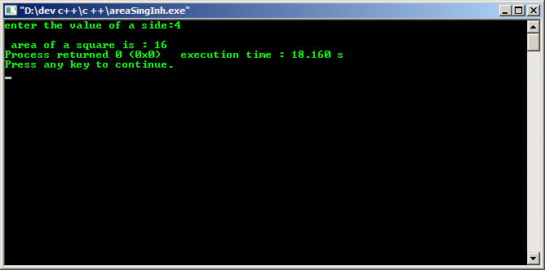

3)

#include<iostream>

using namespace std;

class A

{

public:

int a,b,c,d;

void read()

{

cout<<"enter the value of a and b :";

cin>> a >> b;

}

};

class B : public A

{

public:

void cal()

{

c = a+b;

}

};

class C : public B

{

public:

void cal2()

{

d = a-c;

}

};

class D : public C

{

public:

void dis()

{

cout<<"addition is :"<<c;

cout<<"\n subtraction is :"<<d;

}

};

int main()

{

D d;

d.read();

d.cal();

d.cal2();

d.dis();

}

